**Innovations in Mapping**

**Graphometer Lab**

**2/5/16**

Goals:

* Consider the utility of this instrument
* Experience historical surveying practices
* Reflect on issues of error in historical measurement
* Teach others about the graphometer

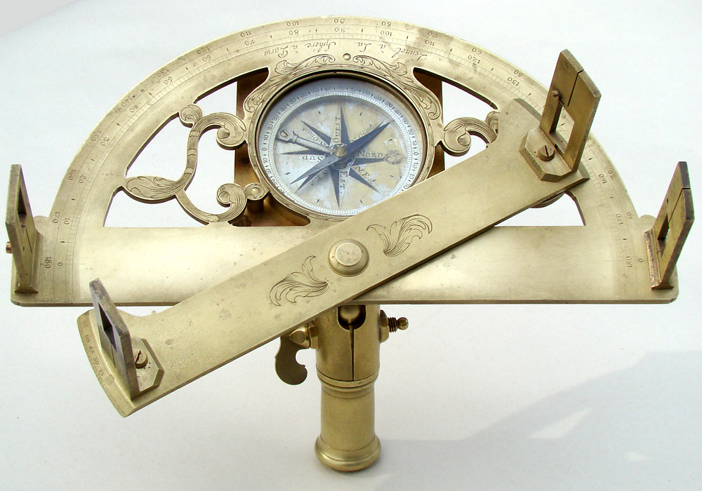

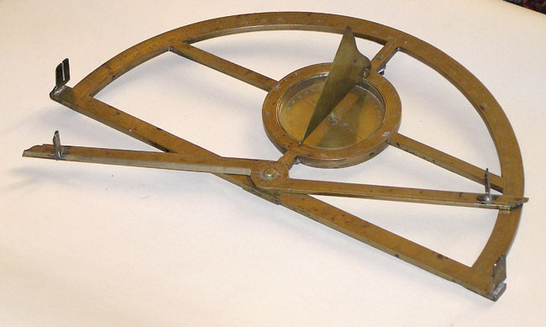Introduction:

The graphometer is an instrument that can be thought of like an early theodolite. It measures horizontal angles with a moveable alidade that pivots along a semicircle. Typically made of brass, some North American models were made of wood. It was invented by Philippe Danfrie in the late 16th century. Below are some images from Danfrie’s 1597 manual describing how to use the graphometer (images from Gallica).

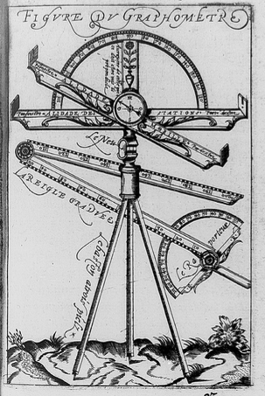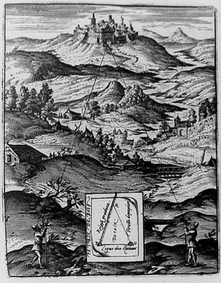

Scenario:

It is 1784. You and your colleagues are French geographers previously employed on the Cassini survey. As a team, you surveyed the natural and built features for the sheets of Provence in southern France in the 1770s. In 1784 you have traveled by boat together to Boston seeking out work to survey the lands where more and more people are settling every year.

Knowing that there is a dearth of scientific instruments, you have brought along some of your instruments to use. Upon arriving in Boston, you meet a wealthy landowner, Mr. Bates, who asks you to explain how you would use a graphometer to help him survey future towns in the north (in what is now Maine). In particular, he requests answers to the following questions:

* What does this instrument accomplish?
* What is the advantage of this instrument?
* What nature and scale of error might occur with this instrument?
* What does this instrument not do? (I.e. what other kinds of measurements would you need to complete a survey? He wants to plan a budget for buying these.)

Additionally, he would like you to write out an exercise to teach others how to use this instrument. If he hires you to travel north, he expects that you will be able to train apprentices.

Drawing on your experience with the Ozanam problems and other examples of geographic or mathematical “recreations,” craft a problem for your future apprentices that helps them understand the utility of the graphometer.

In a letter to Mr. Bates, answer these questions and introduce him to your problem, which you plan to enclose with your letter to him.

Lab Report:

As a group, please hand in one hard copy and one digital copy (by email) of the following:

1. Description of your group’s process for answering these questions/developing the problem.
2. Completed letter with problem attached.

Individually, please hand in one hard copy of a 200-word reflection. You might discuss:

* Challenges of the lab
* Your group’s process
* What you learned
* What you think your group lab report might help others learn.

Both due Thursday, May 5 at 10am

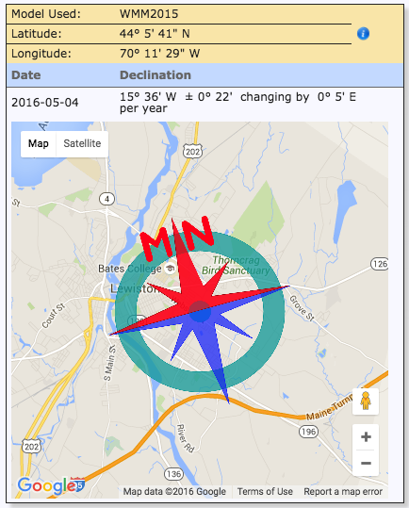

Bates Observatory Location

Latitude: 44.1049

Longitude: -70.2039

Converted to degrees, minutes, seconds:

Latitude: 44 d 6’ 18” N

Longitude: 70 d 12’ 14” W